

**MUSANZE CAMPUS**

**COLLEGE OF SCIENCE AND TECHNOLOGY**

**SCHOOL OF ICT**

**DEPARTMENT OF COMPUTER SCIENCE**

**PROPOSAL PAPER:**

**CRIMINAL INVESTIGATION USING FACE RECOGNITION BASED ON DEEP LEARNING ALGORITHMS**

**Submitted by:**  
***MUROKOZI Jackson: 219006818***

***BYIRINGIRO Bertin: 21900535***

***KASINE Peninah: 219003832***

**Under supervision of**:

BIZIMUNGU Theogene

**August 2022**

# **ABSTRACT**

We are all aware that our face is a distinct and important feature of the human body structure that defines a person. With this advantage, we have proposed a system which will use it to determine the identity of a criminal. With the advent of technology, we will use the installed CCTV in numerous public areas to catch illegal activity. The criminal face recognition system will be created using previously collected faces and criminal photos accessible at the RIB (Rwanda Investigation Bureau). In this research, we present an android base secured criminal identification system using face recognition for the Investigation Bureau in order to improve and upgrade criminal differentiation in a more effective and efficient manner. Using advanced technology, this approach will improve the present system while taking criminal detection to a whole new level by automating duties. Face recognition technology will be used, with photos taken by CCTV cameras; our system will detect the face and recognize the criminals who is entering that public location. The collected photographs of the person entering that public location is matched to the criminal data in our database. If any person's face from a public area match, the system will display their image on the screen and display a message with their name indicating that the criminal has been located and is present in this public location. And the system will alert the admins of RIB and also notify the nearest police station and nearby policemen to catch the identified criminal.

TABLE OF CONTENT

ABSTRACT 1

LIST OF FIGURES 4

LIST OF ABBREVIATIONS 5

CHAP I: GENERAL INTRODUCTION 6

1.1 Introduction 6

1.2 Problem Statement 7

1.3 Objective of the Study 7

1.3.1 General Objectives 7

1.3.2 Specific objectives 7

1.4 General Interests 8

1.5 Scope and Limitations of the System 8

1.6 Technologies 9

1.7 Organization of the report 10

CHAP II: LITERATURE REVIEW 11

2.1 Definition of Terminologies 11

2.1.1 Criminal 11

2.1.2 Face Recognition 11

2.1.3 Open-CV 11

2.1.4 Convolution Neural Network 11

2.2 Existing System 11

2.3 Proposed System 12

CHAP III: RESEARCH METHODOLOGY 14

3.1 Methodological Approach 14

3.1.1 Documentation method 14

3.2.2 Sampling method 14

3.2 System Requirements 15

3.2.1 Hardware requirements 15

3.2.2 Software requirements and development tools 15

CHAP IV: ANALYSIS, DESIGN, AND IMPLEMENTATION 16

4.1 System Analysis 16

4.2 Working Principle of the Proposed System 16

CHAP V: CONCLUSION & RECOMMENDATION 18

REFERENCEES 19

# **LIST OF FIGURES**

***Figure 1****: Types of Identification system 7*

***Figure 2****: Existing System 12*

***Figure 3:*** *Proposed System 13*

***Figure 4:*** *Landmarks on Every Face 16*

***Figure 5:*** *Block Diagram of face recognition 17*

# **LIST OF ABBREVIATIONS**

AES: Advanced Encryption System

AI: Artificial Intelligence

AIS: Automatic Identification System

CCTV: Closed-Circuit Television

CNN: Convolutional Neural Network

CV: Computer Vision

IDE: Integrated Development Environment

JDK: Java Development Kit

MD5: Message-Digest algorithm 5

MIS: Manual Identification System

ML: Machine Learning

NPC: National Police College

Open-CV: Open-Source Computer Vision Library

OS: Operating System

RIB: Rwanda Investigation Bureau

RNP: Rwanda National Police

SDK: Software Development Kit

SQL: Structured Query Language

# **CHAP I: GENERAL INTRODUCTION**

## **Introduction**

Criminal identification is the most vital work for the investigation bureau who are looking for criminals, but it is also the most difficult and time-consuming task since they must locate it everywhere. It is more challenging in densely populated cities or public locations. In certain circumstances, manual identification allows for the gathering of additional information about criminals.

Criminal identification can no longer be a challenge because of existing of advanced technologies in computer vision and images processing where machine learning and artificial intelligence are used with different computer vision algorithms to detect, recognize and identify objects and human faces from a picture or video. As a solution, this research proposal presents an automated criminal identification method based on identifying criminals' faces.

This will help the investigation bureau in identifying and apprehending offenders in public locations [1]. Criminal identification can be accomplished in two methods, as seen in Figure 1.1 Identification in the Manual Identification System (MIS) is done by the investigation bureau officers searching them in public locations. It takes a long time to offer sufficient attention, and it also carries the risk of missing criminals because they would be alerted by seeing officers and quickly escape from there. Because the MIS is taking extra time, we will not be able to adequately focus on everyone. When it comes to an automatic identification system (AIS), however, there is no requirement for public surveillance. All of the processes in this system are automated.

**Identification System**

**Manual Identification System  
(MIS)**

**Automatic Identification System  
(MIS)**

**Figure 1.1**: Types of Identification system

* 1. **Problem Statement**

It is still a difficult and challenging for the investigation bureau to track and find people who have committed sins or people who are suspect of a certain crime. There is a burden in using manual or analog ways of posting pictures of criminals on different platforms, social media or in public waiting for someone to recognize and identify a criminal and call the investigators to come to catch the identified criminal. The processing of the current used strategy is very slow, budget and time consuming. As bad results, it takes too long to track and find the criminals which sometimes give a chance to those criminals to commit crimes again resulting to loss of life and properties. The investigation bureau also spends a lot of money during the process which can end up in a loss. On the other hand, criminals can hide or change their identifications and they can no longer be identified easily. These are caused by not using advance technology to support the investigation and criminals’ identification such as using Computer Vision, AI (Artificial Intelligence), and Machine Learning.

* 1. **Objective of the Study**

### **1.3.1 General Objectives**

The general objectives of our proposed project are to develop an advanced system which identify criminals using face recognition technologies provided by computer vision and enhanced by deep learning algorithms. The system capture and analyses images extracted from different real-time surveillance camera and are handled by image processing, and then compared with the images stored in the database. If images match, the alert will be sent to the administration of the system and to the nearest police station so that the identified criminal gets caught.

### **1.3.2 Specific objectives**

The specific objectives of our proposed project are to:

* Develop a system which can help to identify criminals to support the investigation bureau.
* Develop a system which is accurate and fast to be used in criminals’ identification.
* Develop a system which uses computer vision technology to identify criminals.
* Develop a system which can automatically adopt to change in behaviours of the environment by using Artificial Intelligence (AI) and Machine Learning (ML).
  1. **General Interests**

The interests of our proposed project are:

* Developing a system which can be used by RIB (Rwanda Investigation Bureau)
* Using advanced technologies in criminal identification system.
* Applying knowledge, we covered in information security to give our hands in the existing challenge of identifying criminals in a secured, safe and fast way.
* Extending the application of computer vision technology by implementing it in our proposed android based secured criminals’ identification system.
  1. **Scope and Limitations of the System**

The proposed system to be develop has some scope and limitation. The place in which our research will be based in Rwanda. And our case study will focus on conducting a research based on Rwanda Investigation Bureau. We shall investigate the current strategy done by RIB and RNP to track and identify criminals who are suspect of a crime or criminals who have committed illegal activities in a way of improving the current used system.

The function of the proposed system is to recognize and identify criminals based on recognizing their faces. The system uses a real-time camera which capture video and the system process it into continuous pictures and the by using computer vision algorithms as Open CV and Convolution Neural Network, the captured pictures are processed and compared with those stored in the database.

In the development of our proposed system, we shall use the camera of android devices as CCTV camera in our demonstration and working principle of out proposed system.

* 1. **Technologies**

The proposed system will be developed using different technologies, different programming languages, algorithms and security.

Proposed programming languages to use are:

* Python
* Java
* JavaScript
* XML
* HTML
* CSS

Proposed database and query scripts to use:

* MySQL
* Firebase

Proposed computer vision algorithms to use:

* Open CV
* CNN (Convolutional Neural Network)

Proposed security measures to take to enforce security on our system by protecting data sent within the system:

* The administration dashboard is secured so that only users with admin privileges can access it through the website dashboard.
* In case a criminal is detected, the system alerts automatically the system admins and the nearest police stations and the policemen so that they can catch the identified criminal.
* The passwords are encrypted using MD5 hashing
* They system uses computer vision technology to detect and identify human face
* The system easily adapts to environment changes with the help of Artificial Intelligence and Machine Learning

## **1.7 Organization of the report**

This document is composed of 5 chapters classified as follows:

**Chapter 1**, this chapter provides an overview of the entire project where it contains the general

introduction, background, statement of the problem, choice and motivation of the study, general

objective, specific objectives, scope of the study.

**Chapter 2**, this chapter focuses on describing the current system environment mentioning the

and analyzing how it works and the problems related to it.

**Chapter 3**, this chapter describes the methodology used by the researcher to achieve the stated

objectives and techniques used to collect data. They will help the research by proving real data

from documents and people’s experience which will provide guidance to the system solution.

**Chapter 4**, this chapter presents proposed implementation of the system by explaining how it works, expected results and different diagrams.

**Chapter 5**, this chapter provide conclusion basing on the conducted research and the outcomes

and recommendations to different parties that could be interested in or get advantages from the

system.

# **CHAP II: LITERATURE REVIEW**

# **2.1 Definition of Terminologies**

### **2.1.1 Criminal**

What qualifies someone as a criminal? A criminal is a common phrase for someone who has committed a crime or has been legally convicted of committing a crime. Criminal also refers to being involved in a crime. Criminal activities or individuals are those who are involved in or connected to a crime. [2]

### **2.1.2 Face Recognition**

A facial recognition system is a technology that can match a human face from a digital image or video frame against a database of faces. It is often used to verify users via ID verification services and works by locating and measuring facial characteristics from a given image.[3]

### **2.1.3 Open-CV**

Open-CV is an acronym for Open-Source Computer Vision Library. The library comprises over 2500 optimized algorithms, including a complete range of both traditional and cutting-edge computer vision and machine learning approaches. It also provides C++, PYTHON, JAVA, and MATLAB interfaces that work with Windows, Linux, Android, and Mac-OS. Open-CV is free to use for both business and non-commercial purposes. Open-CV is used to capture photos and videos in public places. [4]

### **2.1.4 Convolution Neural Network**

CNN is a powerful algorithm for image processing. Their algorithms are currently the best existing algorithms for the automated processing of images. They are being used in different place to do things like identifying the objects in an image.

## **2.2 Existing System**

Normally the current system in Rwanda, we have RIB (Rwanda Investigation Bureau) which is the agency responsible to tracking and finding criminals who have committed illegal activities and it can assign tasks to RNP (Rwanda National Police). The way criminals’ identification is performed, is that RIB posts the picture of criminals on the platforms, social media and also, they put different publication in the news, and post banners of their faces in different places so that when someone recognize a criminal basing on the posted photo, he/she can call the investigation bureau. In this case, there can be no accuracy because it is hard to remember someone you saw in a picture, memorize him/her and be able to match the identification with someone you saw in the public. Also, the identification can take to long to find the criminals. [5]

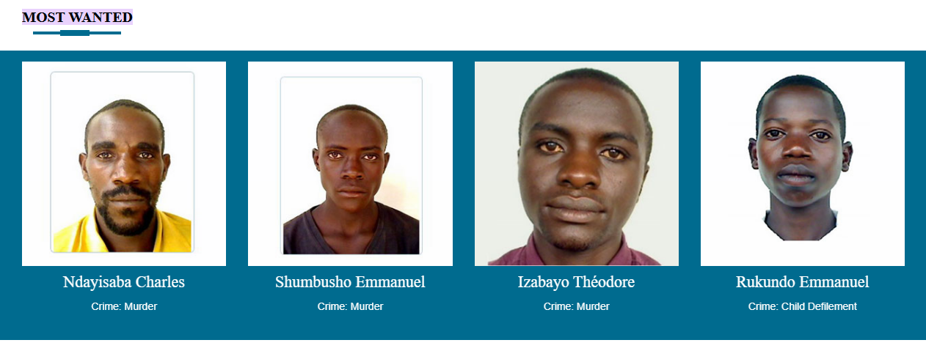

**Figure 2**: Existing System

## **2.3 Proposed System**

In this paper, we use CCTV cameras that are always recording in a public setting. During the system's implementation, we will save criminal photos data with their names on photographs in the database. We will process those photos and extracting features from them, and during feature extraction, and we will be grabbing the face encodings from the current images and storing them into a single file using Android device technology. Using open-CV while capturing CCTV footage and captured images face encodings are placed and compared with our saved face encodings of the criminal database if any match is found then automatically on screen it will display an image of that criminal whose face matches and display the message with his name that criminal found and give an alert to the concerned agency of investigation bureau and also notify the nearest policemen so that they can catch the identified criminal.

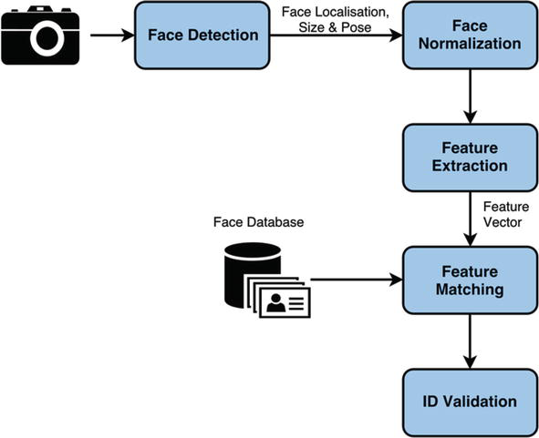

**Figure 3:** Proposed System

# **CHAP III: RESEARCH METHODOLOGY**

## **3.1 Methodological Approach**

A methodology is a broad research approach that describes how the study will be carried out and, among other things, specifies the method to be employed. Methodology describes these approaches, which specify the means or method of data gathering or the way of obtaining a certain outcome. The methodology does not identify a specific methodology, but significant emphasis is placed on the type and type of process, or objective, to be followed in a certain procedure.

In our study we are expecting to use the following data collection methods:

1. Documentation

2. Sampling

### **3.1.1 Documentation method**

Documentation, as you know, is the process of reading a library book and browsing the Internet. Information about them relevant to our topic or inquiry. To obtain a bibliographic search on a topic, use this procedure. Some researchers are interested in researching on a subject that shares some similarities with ours. The information gathered will assist us in developing your project.

### **3.2.2 Sampling method**

Specifications for selecting the population to be included in the survey. As a general rule, use the sampling method. Sampling can be defined as the process of selecting a sample from a particular species or group of people for research purposes. Sampling is the process of dividing a population into a series of parts called sampling units. This sample deals with a population reference to our topic. For example, the scope we have covered is detecting criminals using face recognition.

## **3.2 System Requirements**

### **3.2.1 Hardware requirements**

The system hardware required are:

* Computers such as laptops, desktop, android phones
* RAM with 4GB minimum
* Processor: Intel core or i3 of 2.9HZ minimum, etc
* Hard Disk with 500GB minimum

### **3.2.2 Software requirements and development tools**

The software required are:

* Android studio
* Android SDK
* Open-CV library
* JDK
* WampServer or XAMPP, MySQL
* Text editor like VSCode
* Firebase
* System type 32 bit or 64bit
* Operating System (OS): Windows 8,8.1,10, and windows 11

# **CHAP IV: ANALYSIS, DESIGN, AND IMPLEMENTATION**

## **4.1 System Analysis**

Criminal enrollment is the first stage in recording criminal information in the criminal database. Criminal names and images will be recorded in the database here. Face recognition and identification will be conducted using this image and information. Following the face detection method, picture face encodings will be used. The database procedure is criminal enrollment, but the major step begins with facial detection. As seen in Figure below, face detection takes into account 68 landmarks on the face. CCTV camera collected film or picture is saved, and its properties, such as encodings, are extracted before being compared to image encodings in the database. The face will be matched in the database, and the name and the criminal detected message will be shown beside the criminal image on the screen in the CCTV Room.

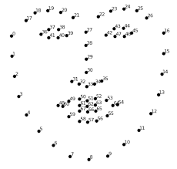

**Figure 4:** Landmarks on Every Face

## **4.2 Working Principle of the Proposed System**

We are employing CCTV cameras to capture photographs of members of the public in order to identify the appropriate person who has a criminal record in the database to apprehend.

1. First, we will extract the facial encodings from the criminal database photos and save them in one list, while dividing the name recorded with the criminal image into another list.

2. We will then be deploying CCTV to collect public pictures in order to identify and easily apprehend criminals who are present in public places.

3. Taking the acquired photos' face-encodings and extracting the features from them.

4. Using our database image encoding values to compare captured picture encoding values.

5. If the encoding values match those of the taken image, the criminal image, name, and message will be shown on the screen.

6. The image of that individual will be saved to a separate folder, allowing investigation bureau to readily identify the criminal whose identification matches.

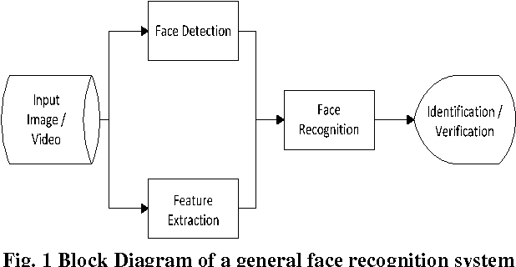

**Figure 5:** Block Diagram of face recognition

# **CHAP V: CONCLUSION & RECOMMENDATION**

Face Recognition Technology has the ability to aid in the resolution, prevention, and prosecution of crimes. More precisely, it might be beneficial for a variety of investigations, such as determining the identity of an ATM fraud suspect, searching for a terrorist in public places, combating child abuse, or even locating missing individuals. On the other hand, early evidence suggests that without sufficient control, face recognition technology might result in human rights violations and hurt civilians. That is why the government must be involved to ensure that it is used legally.  
  
This improved version of the criminal detection system not only makes it easier for the investigation bureau to identify criminals, but also saves them time because the processes are automated in the system. Face detection utilizing Face Encodings is the innovative aspect of this Research Paper.

For further research, we recommend that, because CCTV are static and not dynamic, we can incorporate drones which have camera to support the tracking and they might be moving around scanning people instead of waiting for the criminals to reach the place where CCTV are statically installed.

# **REFERENCEES**

[1] Ratnaparkhi, S. T., Tandasi, A., & Saraswat, S. (2021, January). Face Detection and Recognition for Criminal Identification System. In 2021 11th International Conference on Cloud Computing, Data Science & Engineering (Confluence) (pp. 773-777). IEEE.

[2] Tappan, P. W. (1947). Who is the Criminal?. American Sociological Review, 12(1), 96-102.  
[3] Tolba, A. S., El-Baz, A. H., & El-Harby, A. A. (2006). Face recognition: A literature review. International Journal of Signal Processing, 2(2), 88-103.

[4] Bradski, G., & Kaehler, A. (2000). OpenCV. Dr. Dobb’s journal of software tools, 3, 120.

[5] <https://www.rib.gov.rw/index.php?id=371#:~:text=US%20ON%20TWITTER-,MOST%20WANTED>